Crystal Reports Database Connections
Choose “Microsoft OLE DB Provider for SQL Server” (highlighted) when making a new connection.
Do NOT choose the one in blue, “Microsoft OLE DB Driver for SQL Server”.
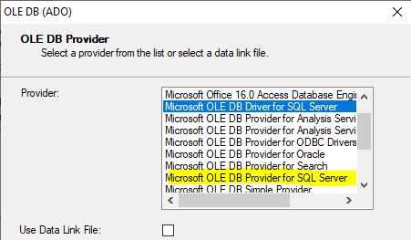
This is how the correct Provider looks in the properties.
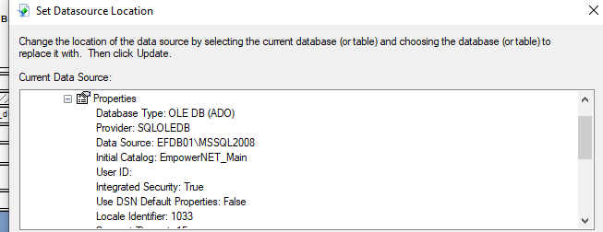
This is how the incorrect Provider looks in the properties.
